Double Colon Operator (::)
Method Reference and Constructor Reference by ::
Example - Lambda Expression provide implementation for functional interface:
Interface Interf{
Public vod m1();
}

Class Test {
Public static void main(String args[]){
Interf i=() -> {
Sop(“test”);
;;;;
};
i.m1();
}
}

Method Reference by double colon provide implementation for functional interface:
Interface Interf{
Public vod m1();
}

Class Test {
Public static void m2(){
Sop(“hello m2”);
;;;
}
Public static void main(String args[]){
Interf i=Test::m2();
i.m1();
}
}

If the implementation is already available in m2(), so we can reuse or refer this method to the abstract method of m1() like below.
Interf i=Test::m2();
i.m1();

So in the place m1() we can use m2() to execute. This m2() can be static or instance method but the method argument must be same. Functional interface method m1() internally refers the m2() of Test class. Even though we are calling m1(). But internally it calls the m1() of Test class.

Advantage:
Code reusability. Instead of providing new definition for functional interface method, we can use the existing functionality.

Condition to use:
Referring and Referer(target method) method both should have same argument types. Method names, modifiers and return type can be different. Also the referrer or target method can be static or instance method.

Conclusion:
Method reference is alternative syntax to lambda expression.

If the referrer method is static, then use below syntax to refer using :: operator:
Classname :: methodname

If the referrer method is non static,then
ObjectRef :: methhodname

Ex: Test t=new Test();
t :: m2;

Note : A functional interface can be implemented by following types

Consider Runnable interface,
It is implemented by,
- Runnable r =new MyRunnnable(); By extending a separate class.
- Anonymous Inner class implementation
- Lambda expression
- Method Reference

Example – Method Reference Implementation for Runnable Interface
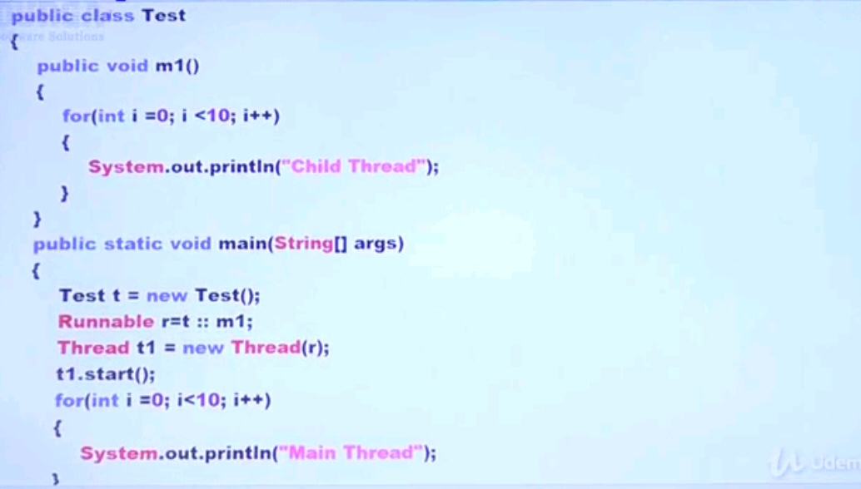

Constructor Reference by Double Colon operator:

Example using lambda expression:
Class Sample{
Sample(){
Sop(“Constructor Reference”);
}
}

Interface Interf{
Public Sample get();
}

Class Test{
Public static void main(String args[]){
Interf I = () -> {
Sample s=new Sample();
Return s;
};

Sample sample=i.get();
}
}

Example using Constructor Reference:
Class Sample{
Sample(){
Sop(“Constructor Reference”);
}
}

Interface Interf{
Public Sample get();
}

Class Test{
Public static void main(String args[]){
Interf I = Sample :: new;
Sample sample=i.get();
}
}

Syntax to use:
Classname :: new;

